**DATA VISUALIZATION**

**ASSIGNMENT 1**

**Rabia Mustafa**

**20I-1853**

**----------------------------------------------------------------**

**This assignment is based in two sections**

**Section 1**

->Analysis of water in Rivers that are one of the reason of floods

**Section 2**

->Analysis Of side effects that are caused due to flood

**Section_1**

**In Section 1 I have done ANALYSIS ON TWO MAIN POINTS**

**1_Inflow and Out Flow of Rivers**

**2_ Qualitative Forecasted Flood**

For this purpose, I have Scrapped Data of 3 different Dates So analysis and comparison can be done Easily.

**1_Inflow and Out Flow of Rivers**

**PLOTS:**

**Graph 1**

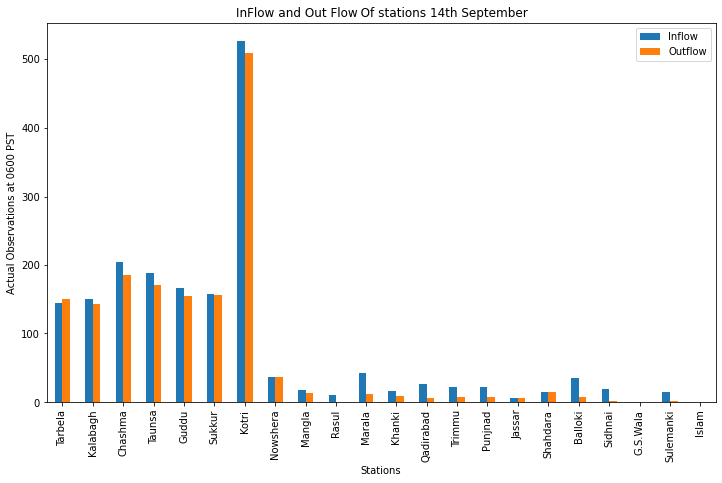

**Analysis and Insights:**

This analysis Shows that maximum of the water is in kotri station there is a difference of 100 of PST observation in each graph that represents that water in this station is decreasing and situation is becoming normal.

**2_ Qualitative Forecasted Flood**

**Plots:**

**Graph_1**

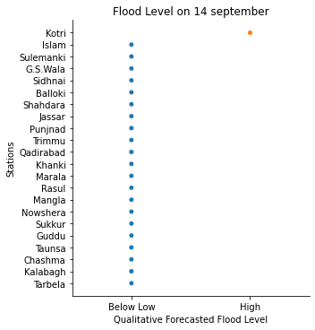

**Graph_2**

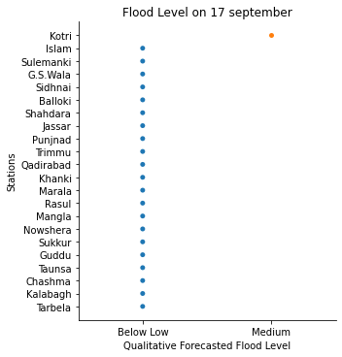

**Graph_3**

**ANALYSIS** **and Insights:**

Above three graph shows flood level Risk on 14,17,19 September 2022.

From above three graphs it can be concluded that there was risk of flood because of water in kotri Station but this risk is decreasing day by day, water level is coming to normal. Beside that all other stations have normal water level; they are out of danger of flood.

**SECTION 2**

In this Section I have done analysis of side effects that are caused due to flood.

**Part1)**

Reprsentation of Damages and Reconstruction Cost in Different SECTORS that is caused because of massive Flood.

**Graph:**

**Analysis:**

This Graphs shows Damage and Reconstruction Cost of Various Sectors. We can drive that damage and reconstruction cost of most of the sectors is below 500USD.

However, housing sector has damage and reconstruction Cost is about 1000USD.

Highest Damage is in Fisheries Sector, but its reconstruction Cost is less than the damage Occurred.

**Note:** In the graph Energy, Health, Education, Water Supply, Environment and Governance sectors have very poor visualization as they are in very small amount, so they are unable here to visualized independently. Because of this Reason I have plotted them separately.

**Below are their Graphs:**

**Graph:2,3

**Graph:6,7**

**PART 2)**

IN part 2 I have Represented Crop AREA DAMAGED IN Different Provinces.

**Plot1)**

**Analysis**: In Balochistan **Rice** is the major crop that is **affected** because of flood.

**Plot2)**

**Analysis**: In Sindh **Cotton** is the major crop that is **affected** because of flood.

**Part 3)**

* This part of Assignment Represents the direct damage in:
* Distribution
* Transmission
* Total Power
* oil and Gas

**PLOT:**

**Analysis:**

**Maximum** damage is in **Power** Sector. Whereas **minimum** damage is in **Transmission** Sector.

**PART 4)**

**It represents overall Direct and Indirect Damages in Provinces.**

**PLOT:**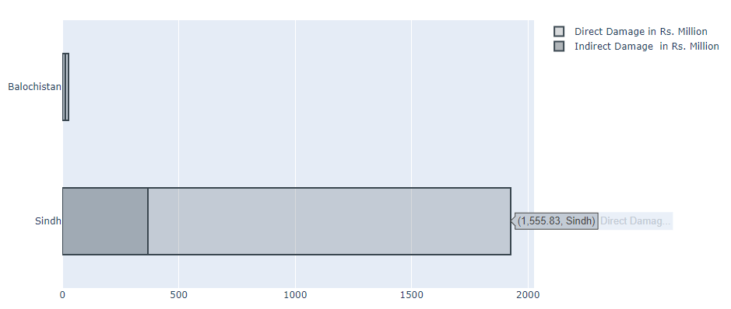

**Analysis:**

Direct and indirect damage in Sindh is more as compared to Balochistan.

**PART 5)**

**In this part Recovery and Reconstruction Needs Assessment Summary is plotted.**

**PLOT 1:**

**Analysis:** In this analysis Rehabilitation Cost in Sindh is more as compared to Capacity Building cost.

**PLOT 2:**

**ANALYSIS:** In this analysis Rehabilitation Cost in Balochistan is more as compared to Capacity Building cost.

**-----------------------------------------------------------------------------------------------**